**Chapter 6**

**Applications of Integration**

**6.1 Areas between Curves**

**Section Exercises**

**For the following exercises, determine the area of the region between the two curves in the given figure by integrating over the**

1. 

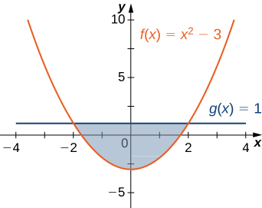

Answer:

**For the following exercises, split the region between the two curves into two smaller regions, then determine the area by integrating over the *x*-axis. Note that you will have two integrals to solve.**

3. and

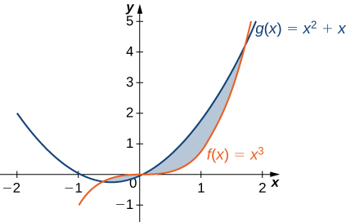

Answer: 

**For the following exercises, determine the area of the region between the two curves by integrating over the *y*-axis.**

5. 

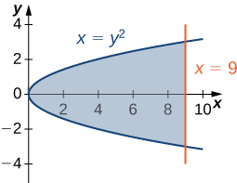

Answer:

**For the following exercises, graph the equations and shade the area of the region between the curves. Determine its area by integrating over the *x*-axis.**

7. 

Answer:

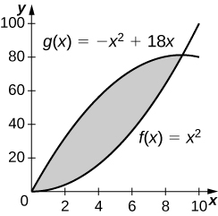

243 square units

9.  and  on

Answer:

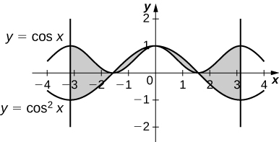

4

11. 

Answer:

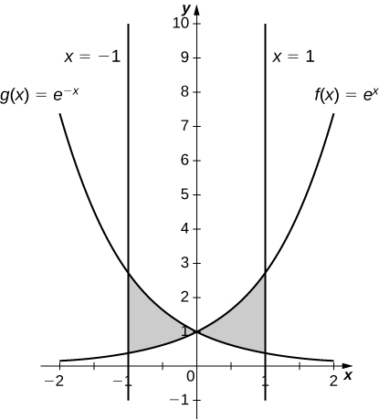



13. 

Answer:

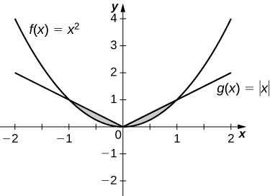



**For the following exercises, graph the equations and shade the area of the region between the curves. If necessary, break the region into sub-regions to determine its entire area.**

15. 

Answer:

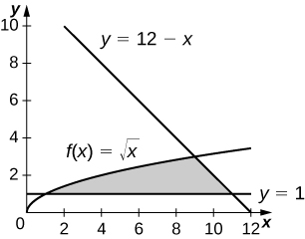



17.  over

Answer:

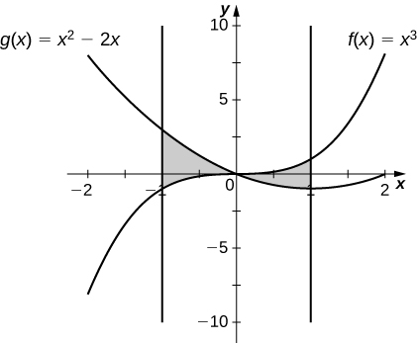



19.  and 

Answer:

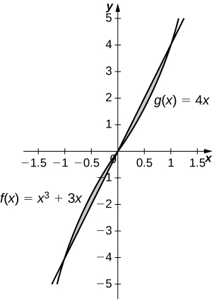



**For the following exercises, graph the equations and shade the area of the region between the curves. Determine its area by integrating over the *y*-axis.**

21. 

Answer:

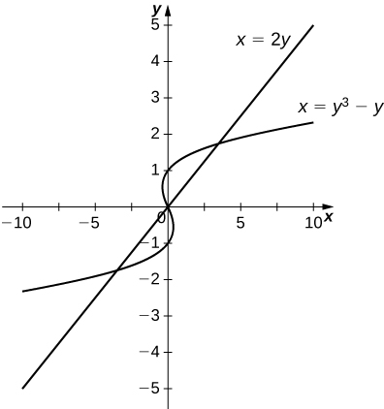



23. 

Answer:

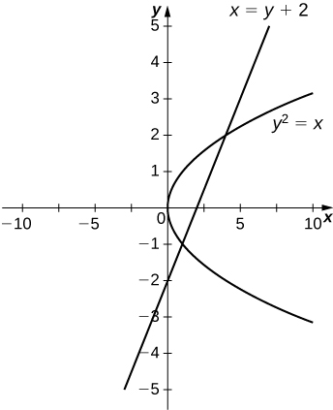



25. 

Answer:

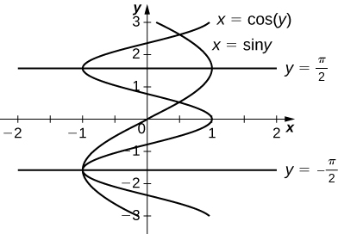



**For the following exercises, graph the equations and shade the area of the region between the curves. Determine its area by integrating over the *x*-axis or *y*-axis, whichever seems more convenient.**

27. 

Answer:

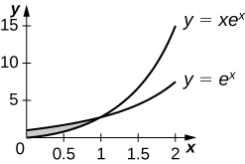



29. 

Answer:

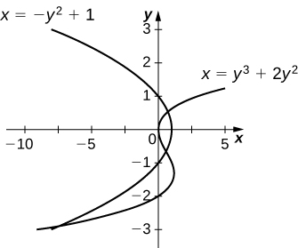



31. 

Answer:

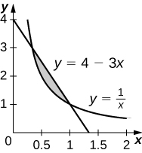



33. 

Answer:

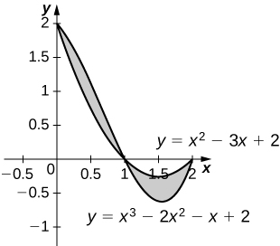



35. 

Answer:

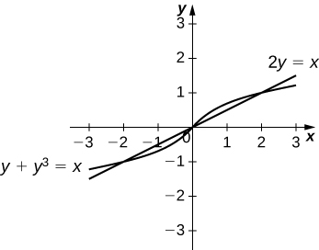



37. 

Answer:

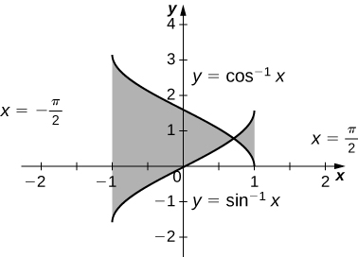



**For the following exercises, find the exact area of the region bounded by the given equations if possible. If you are unable to determine the intersection points analytically, use a calculator to approximate the intersection points with three decimal places and determine the approximate area of the region.**

39. **[T**]

Answer:

41. **[T**]

Answer:

43. **[T**]

Answer:

45. **[T**]

Answer: 

47. **[T**]

Answer:

49. A factory selling cell phones has a marginal cost function.  whererepresents the number of cell phones, and a marginal revenue function given by. Find the area between the graphs of these curves and. What does this area represent?

Answer:  total profit for  cell phones sold

51. The tortoise versus the hare: The speed of the hare is given by the sinusoidal function  whereas the speed of the tortoise is  where is time measured in hours and the speed is measured in miles per hour. Find the area between the curves from time  to the first time after one hour when the tortoise and hare are traveling at the same speed. What does it represent? Use a calculator to determine the intersection points, if necessary, accurate to three decimal places.

Answer:  mi represents how far ahead the hare is from the tortoise

**For the following exercises, find the area between the curves by integrating with respect to *x* and then with respect to *y*. Is one method easier than the other? Do you obtain the same answer?**

53. 

Answer: 

55. 

Answer: 

**For the following exercises, solve using calculus, then check your answer with geometry.**

57. Find the area between the perimeter of the unit circle and the triangle created from  and , as seen in the following figure. Is there a way to solve this without using calculus?

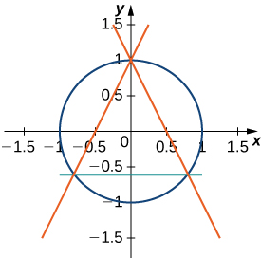

Answer:

This file is copyright 2016, Rice University. All Rights Reserved.